Name:____________________________________________ Date:________________ Period: _______

HW Quiz 4 – Toy Car Collision (10 Points)
The FLOWER car starts at the +2.8 m mark and the ARMY car starts at the -1.4 m mark. The two cars are put in motion on a path for a head-on collision. If the FLOWER car has a speed of __________ cm/s and the ARMY car is traveling at __________ cm/s.
a) Sketch a Position vs Time graph of the two cars’ motion on the axes below (make sure to clearly label each car)
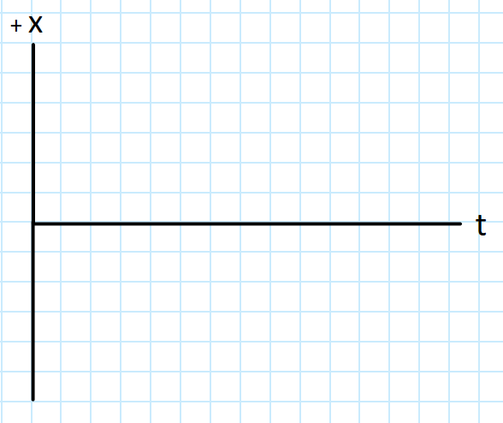

b) Write an equation to model the motion of each car:
FLOWER: _________________________________________ ARMY: ____________________________________________

c) Where will the two cars meet? (Show your work for credit)

Name:____________________________________________ Date:________________ Period: _______

HW Quiz 4 – Toy Car Collision (MAKE-UP)
The FLOWER car starts at the +3.2 m mark, and the ARMY car starts at the -2.4 m mark. The two cars are put in motion on a path for a head-on collision. If the FLOWER car has a speed of 0.42 m/s and the ARMY car is traveling at 0.28 m/s.
a) Sketch a Position vs Time graph of the two cars’ motion on the axes below (make sure to clearly label each car)


b) Write an equation to model the motion of each car:
FLOWER: _________________________________________ ARMY: ____________________________________________

c) Where will the two cars meet? (Show your work for credit)

Name:____________________________________________ Date:________________ Period: _______

HW Quiz 3 - A (10 Points)
$$s=\frac{d}{t} v=\frac{∆x}{t} x_{f}=vt+x_{i}$$
The FLOWER car starts at the __________ m mark and the ARMY car starts at the __________ m mark. The two cars are put in motion on a path for a head-on collision. If the FLOWER car has a speed of __________ cm/s and the ARMY car is traveling at __________ cm/s, where will the two cars meet?

Name:____________________________________________ Date:________________ Period: _______

+Positive Physics – HW-Quiz 3 - B (10 Points)
$$s=\frac{d}{t} v=\frac{∆x}{t} \overline{v}=\frac{v_{i}+v_{f}}{2} x_{f}=vt+x_{i}$$
An Airbus A320 lands with a speed of 150 mph and slows to a stop at a steady rate in 16 seconds. Due to an unfortunate bathroom incident, the plane is forced to make an emergency landing at a small airport with a runway just 3000 m long. Will the Airbus A320 be able to land safely? (Must support your answer with numbers). 1 mile = 1609 m.

Name:____________________________________________ Date:________________ Period: _______

+PositivePhysics – HW-Quiz 3 - B (10 Points)
$$s=\frac{d}{t} v=\frac{∆x}{t} \overline{v}=\frac{v_{i}+v_{f}}{2} x_{f}=vt+x_{i}$$
An Airbus A320 lands with a speed of 150 mph and slows to a stop at a steady rate in 16 seconds. Due to an unfortunate bathroom incident, the plane is forced to make an emergency landing at a small airport with a runway just 3000 m long. Will the Airbus A320 be able to land safely? (Must support your answer with numbers). 1 mile = 1609 m.

